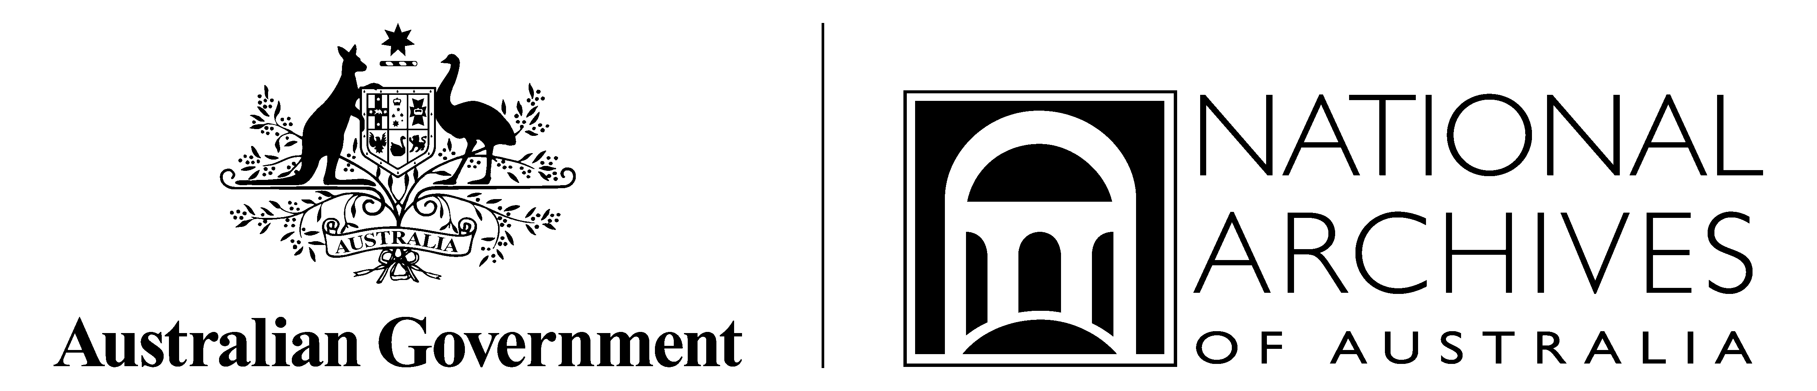

Order of Proceedings

Speakers Corner: Gwalwa Daraniki! The Larrakia petition
Menzies Room, National Archives of Australia, Parkes

(Draft as at 23 May 2011)

Date: | Sunday 29 May 2011
Time: | 2.00 – 3.00 pm
Location / Venue: | Menzies Room  National Archives of Australia, Queen Victoria Terrace, Parkes
MC: | Dr Stephen Ellis, Acting Director-General
Speaker: | Dr Bill Day  Mr Daniel May
Events staff: | Janelle Wilson, Jo Wilson

Time | Activity | Details
12.45pm | Janelle Wilson and Jo Wilson arrive.
1.00pm TBC | Suellen Bailey arrives to set up Larrakia petition and facsimile in Menzies Room. | Trestle tables on stage.
1.00pm | Dr Bill Day and Mr Daniel May arrive. | Test sound and presentation in Menzies Room.
1.30pm | Stephen Ellis arrives and meets speakers.
2.00 pm | Stephen Ellis as MC welcomes guests, acknowledges the traditional owners of the land, introduces the lecture topic and speaks about the preservation of the petition. Introduces the first speaker- Dr Bill Day. | Larrakia petition and facsimile on table on stage.
2.10pm | Dr Bill Day speaks for approx. 20 minutes.  Hands over to Mr Daniel May. | Slideshow of images on screen.
2.30pm | Mr Daniel May speaks for approx. 20 minutes. | Slideshow of images on screen.
2.50 pm | Stephen Ellis facilitates audience questions. | Events staff with roaming microphones.
3.00 pm | Stephen Ellis thanks Dr Bill Day and Mr Daniel May, and invites guests to view the petition, and exhibitions. | Petition & facsimile on table on stage for viewing. Conservator on hand for questions.
3.00 pm | Event concludes.

